**1. What are the different margins options and do we adjust the margins of the excel worksheet?**

**Ans:**

In Excel, if you want to print a paper report, you have the option to change the page margins according to your need. By default, the margins that you have are 1.78 cm for the left and right, and 1.91 for the bottom and top.

* Change Page Margin in Excel

1. First, go to the Page Layout Tab.
2. After that, go to the page setup option group.
3. Next, click on the “Page Layout” drop-down.
4. In the end, select the page margin setting that you want to use.

* Custom Page Margins

1. When you margin drop-down from the page layout,
2. Click on the “Custom Margin” option,
3. Open the dialog box
4. In the dialog box, you can change the page margin values and set a new one.

**2. Set a background for your table created.**

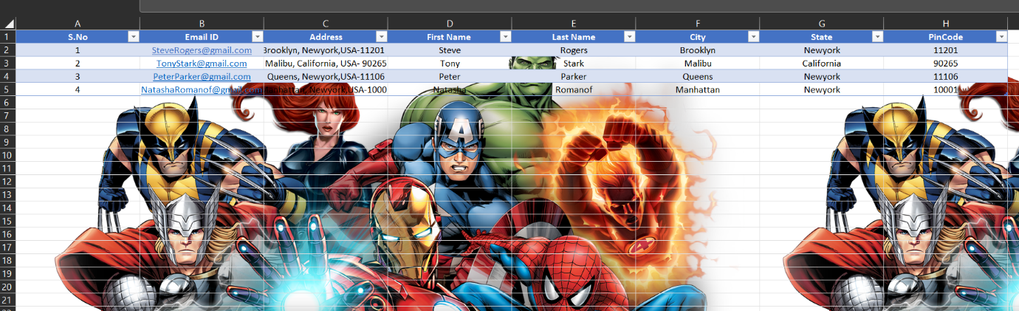

**3. What is freeze panes and why do we use freeze panes? Give examples.**

**Ans:**

It "freezes" a row or column, so that it is always displayed in place, regardless of what part of the spreadsheet is being displayed. When the user scrolls vertically or horizontally through an open spreadsheet, everything scrolls except the frozen row or column. Freezing panes is especially useful if your spreadsheet has a header row, that you want to always be visible.

1. Open the spreadsheet.
2. Click View.
3. In the View tab, click Freeze Panes and select the freeze option you want to choose. For example, choose Freeze top row to freeze the top row.
4. Earlier versions of Microsoft Excel and other spread sheet programs
5. Open the spreadsheet.
6. Using your mouse, highlight the entire row or column. For example, if you wanted to select row 1, click the row header 1.
7. Finally, select the Freeze pane option in the menu bar and choose the appropriate option.

* Tip: You can also unfreeze the row or column by repeating the above steps.

**Example** :

1. Select the row below the row(s) you want to freeze. In our example, we want to freeze rows 1 and 2, so we'll select row 3.

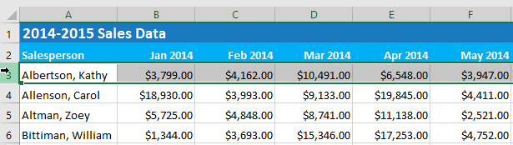

1. On the View tab, select the Freeze Panes command, then choose Freeze Panes from the drop-down menu.

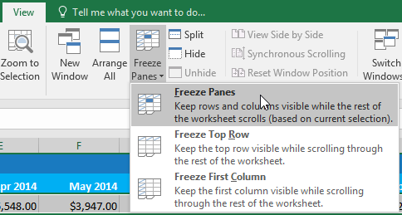

1. The rows will be frozen in place, as indicated by the gray line. You can scroll down the worksheet while continuing to view the frozen rows at the top. In our example, we've scrolled down to row 18.

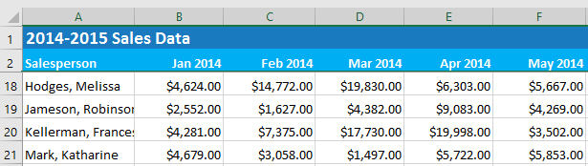

**4. What are the different features available within the Freeze Panes command?**

**Ans:**

Excel enables three methods to freeze the pane.

1. Freeze Pane
2. Freeze Top Row
3. Freeze First Column



**5. Explain what the different sheet options present in excel are and what they do?**

**Ans:**

Sheet Options MS Excel provides various sheet options for printing purpose like generally cell gridlines aren’t printed. If you want your printout to include the gridlines, Choose Page Layout » Sheet Options group » Gridlines » Check Print.

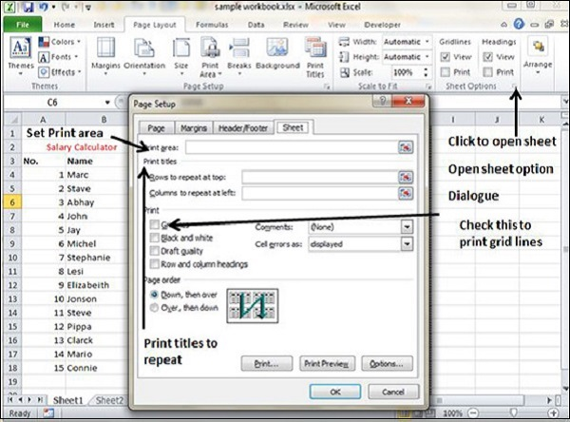

* Options in Sheet Options Dialogue

1. Print Area − You can set the print area with this option.
2. Print Titles − You can set titles to appear at the top for rows and at the left for columns.

* Print −

1. Gridlines − Gridlines to appear while printing worksheet.
2. Black & White − Select this check box to have your color printer print the chart in black and white.
3. Draft quality − Select this check box to print the chart using your printer’s draft-quality setting.
4. Rows & Column Heading − Select this check box to have rows and column heading to print.

* Page Order −

1. Down, then Over − It prints the down pages first and then the right pages.
2. Over, then Down − It prints right pages first and then comes to print the down pages